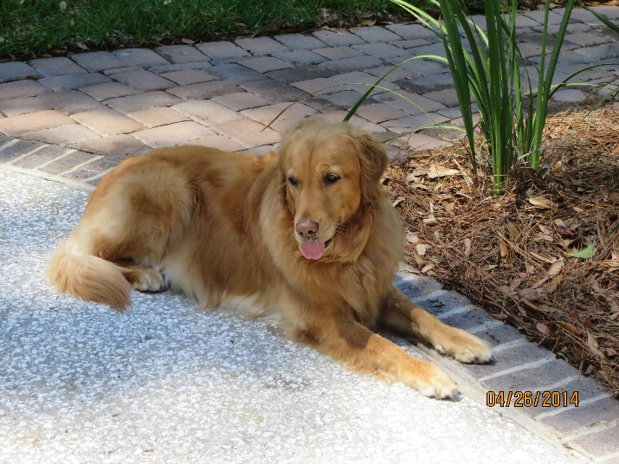

We are deeply saddened to tell you that our beloved Stella passed over the Rainbow Bridge today, Monday, January 16, 2023. She was with us for over 11 years and gave us more joy and love than we could have hoped for. We adopted her at age one from Grateful Goldens of the Low Country and are incredibly thankful to them for this opportunity. She loved everyone with whom she came into contact.
Her passing will leave a large hole in our lives and we will miss her every day for a long time, but we will have memories that will last for the rest of our lives. We could not have asked for a better friend, companion and fellow traveler. She was always up for a ride in the car or golf cart and the further we went, the happier she was. She loved to chase squirrels, cats and large birds in Savannah, and never seemed to mind that she never caught any. She loved the water and especially the ocean and enjoyed our vacations to the N.C. beaches.
Good bye lovely girl and know that you will be in our hearts forever.
Mike and Barbara Werneke

